|  |
| --- |
| **YELLOW ROOM NEWS**  Mrs. Barshinger Ms. Klossing **Aug. 27, 2018**  Additional info on the web: **http://brightfutures205.weebly.com/yellow-room.html** |

**New Story**

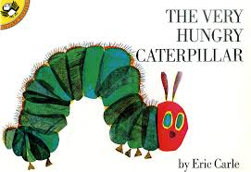

Here is the link for The Very Hungry Caterpillar read by the author himself, Eric Carle.

[**https://www.youtube.com/watch?v=vkYmvxP0AJI**](https://www.youtube.com/watch?v=vkYmvxP0AJI)

**You can see find some of the stories we read on YouTube!**



Here is the link for

Pete the Cat: I Love My White Shoes

<https://youtu.be/FiO-xIZxmJE>

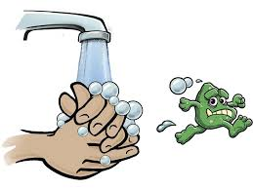

**Thank you** for practicing using the handwashing visual we gave out at the welcome visit. On the back is the handwashing song that we will be singing. It’s to the tune of “Where is Thumbkin?”

* **Spiderman ball cap**
* **Gray and red nature trail jr. jacket**
* **Snowbull wristband**

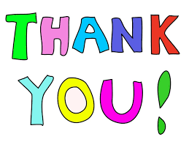**We are thankful to our Knox Students who are volunteering the last five weeks of school: Ms. Carmen, Ms. Ashley,and Ms. Lydia.**

**We thank Mr. Cahill and Mr. Lyon for coming in weekly to read one on one to the children.** One of the best ways to prepare your child for reading is to read to them and have conversations!

**We welcomed Roselin and her family to the PM class this week.**

The note that came home regarding preschool screenings is for children not enrolled in the program. If your child still has another year of preschool left after this year, you do not need to have them screened again. Your child would be able to come again next year. Those children turning 5 before September 1st will be eligible to attend kindergarten.



We are going to be reading several stories this week and paying attention to the feelings of the characters in the story (happy, sad, scared, lonely). Ms. Debbe is coming back on Friday and is going to do some sketching with the children. She will talk about colors and feelings in the process.

Next Family Night will be February 16th. Details will be coming your way. Save the date.



We welcome **Travis** and his family back to the Yellow Room in the morning. Travis is to be a big brother soon.

We also welcome **Amirra** and her family to the morning class.

**Abran** will soon be starting in the afternoon class. We welcome him and his family to the Yellow Room.

**We have enjoyed the classroom visits so far. It is really a special time for the children to show parents what they do at school.



Here is a You Tube version of the song **Five Little Gingerbread** we learned:

<https://www.youtube.com/watch?v=wCZ3dzFK6BI>



**Thank You**

Thank you for the many donations of tissues. We have a good supply right now.

We thank Mr. Cahill in the morning class and Mr. Lyon in the afternoon class. They come to the Yellow Room once a week to read one on one to each child. Reading to your child is one of the best things you can do to prepare them for kindergarten. If you need books at home, please contact me immediately. We can devise a plan for sharing.

<http://www.thenutfamily.com/songs.html>

We wish Bryson (AM class) and his family well in their new home. We will miss you in the Yellow Room!

**Goldfish Crackers**

We had a mix of **cheddar** and **pretzel** goldfish crackers. The children **sorted** them into two groups before eating. Our goal is for them to be able to **sort** items into groups and then **tell** how they sorted those items. What can you sort around the house?



We appreciate the many donations that have come into the Yellow Room. Also, thank you for your commitment to parent-teacher conferencing. Your partnership is why you are seeing growth in your child.



**Please sign up**

Part of the commitment to success in preschool is the parent/teacher conference. You will get to see pictures, ask questions, and share valuable information that will help us plan for the rest of our year.

Note: Attached is the sign-up sheet. If you have another child in the program, we will try to have the conferences back to back.

**COMPOUND WORDS**

(see game on back)

**Compound Boogie**

<https://www.youtube.com/watch?v=jP88434Whjs>

Cooking and eating together make for many opportunities to learn math and science. ☺



**Notice the changes??**

**Focusing on being Helpful**

**Enjoy reading together!**

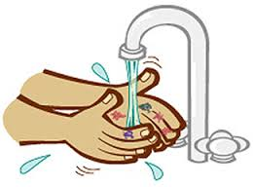

On back, there is a copy of the Hand Washing Story that we use at school. Please continue to review with your child. Remember you can also point out the letters and numbers.



**Arrival Routine**

* Unzip backpack and give teacher any notes. Please practice.
* Get mail from cubby and put in backpack. Zip and put backpack in the big bag.
* Go to table time.

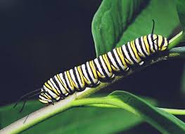

**Monarch Caterpillars**

Our school is crawling with these little critters who eat milkweed and poop. The poop is called frass. Check out the video from last year on our classroom website.

Four of the caterpillars have already formed a chrysalis.

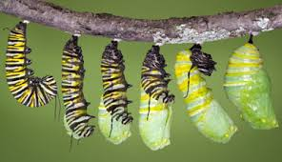

**SAVE THE DATE – Saturday, September 8th is the Monarch Festival out at Lakeside Nature Center. More info to come.**

We did quite a bit of observing last Friday. Some of the children even drew pictures. Our goal is to have the children become very observant of what they see and to describe it using color, shape, texture and so forth.

We have also been looking at bugs that are living and not living.

**Important Dates**

**August 27th and 28th**

Early Dismissal for PM Class is 2:30 pm due to the heat forecast. You should have received Skyward message.

**Monday, September 3rd**

No School – Labor Day



**Social Emotional Learning**

We are spending the first week of school working on getting to know our SCHOOL FAMILY. You may here your child saying the following chant:

***_______ came to school today.***

***We’re so glad we’ll shout hooray!***

We also see if anyone in our class is missing. If so, we put them in our heart and sing:

***We wish you well.***

***We will you well.***

***All through the day today.***

***We wish you well!***

We thoroughly enjoyed all of the welcome visits with both returning and new families. We even got a few home visits done.

If you would like to learn more about the Conscious Discipline we are learning, go to

<https://consciousdiscipline.com>

***_____ more days, then we put away the toys, turn out the lights, lock the doors, and go home for summer.***

See the attached article entitled, **“Saying Good-Bye to Preschool.”**

**You can learn more at the Conscious Discipline website:**

[**https://consciousdiscipline.com/about/conscious-discipline-for-parents.asp**](https://consciousdiscipline.com/about/conscious-discipline-for-parents.asp)

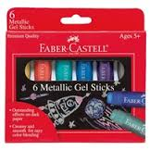

Due to unforeseeable circumstances, we have not been able to provide the parent workshops this year at Bright Futures. We do have some wonderful **Conscious Discipline DVD’s** **and audios** that could be available for listening/viewing if you desire. Here are a few of the topics. Let Mrs. Barshinger know if you are interested.

***Transforming Aggression into Healthy Self-Esteem***

***Preventing Power Struggles***

***10 Principles of Positive Discipline***

***Conflict Resolution***

***Best Beginnings***

***Parenting without Guilt***

We also have **Trust Based Relational Intervention DVD’s** to bring hope and healing to families who have been through trauma.

**“It’s my job to keep the school safe. It’s your job to help keep it safe.”**

***Sophie is a STAR***

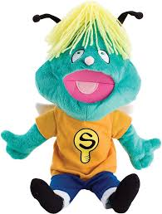

***Sophie Makes a Choice***

***Sophie’s Helpful Day***

***Sophie’s Big Voice***

We will continue to work on having the children express themselves using feeling words.

“I am mad.” **Pause and breathe**

“ I’m feeling mad because…..

“I choose to _______ to help me calm and solve the problem.

[](http://www.bing.com/images/search?q=music+notes&view=detail&id=53AA7E7BCCBE954D8F1A6535FE9719202E2E1FF9)**Group Music on Fridays**

All classrooms meet in the gym at 11:00 am & 3:00 pm to sing together. Parents are welcome to join us.

**Labeling Feelings**

One of our goals is to help children be able to put words, or label, their feelings. Just the act of labeling how they feel, gets the brain ready to actually figure out how to handle those feelings. What we want the children to know is that feelings are OK, but how we respond to feelings have boundaries.

For example, it is OK to be angry, but it is not OK to destroy the toys, hurt others, or hurt yourself.

The safe place is a great place to go and figure out how to calm first and then solve the problem. This skill is not mastered in the preschool years. It takes co-regulation with adults who are in control of their own emotions. This is easier said than done, but we work on it daily in the classroom.

**Showing respect**

**It is important to teach children to treat themselves and others with respect.** This means respectful voice, facial expressions and attitudes, others’ space, and belongings. We will be working on what it means to ask with respect and celebrate when the child does it. In role-play, we first show the child what it looks like with no respect and then with respect. Practice can be fun and playful.

***Child****: “I want a cookie.”*

***Adult****: Try again with respect.*

***Child:*** *“Mom, may I have a cookie?”*

***Adult:*** *That’s it. You did it. You asked with respect.*

**THE WEBSITE IS AT THE TOP OF THIS NEWSLETTER. ☺**

You can also go directly to the You Tube video.

https://www.youtube.com/watch?v=qDqOG0RIiSE

***Choices***

*The adult punishes aggressive acts and removes aggressors from the situation or classroom, while largely ignoring the victim. Alternately, the adult may speak to aggressor about their wrong or hurtful behavior and ask them to apologize. The adult may soothe or coddle victims.*

***FULLY FUNCTIONAL DEVELOPMENT AND IMPLEMENTATION***

*The adult goes to the victim first and notices, “Your hand is going like,” or asks, “Did you like it?” The adult coaches the victim to say, “I don’t like it when you ____. Please _____. The adult is adept at helping children learn an assertive tone and telling others how they want to be treated. The adult then approaches the aggressors with the phrase, “You wanted _____,” and teaches them how to assertively communicate (“May I have a turn?), instead of using an aggressive act (grabbing) to get what they want. Children are beginning to use this language regularly and more independently.*

The adult encourages children by noticing and describing instead of judging. The intent behind the encouragement is to help children become conscious of their  
efforts and actions, not compliance. “Good job” becomes “Good for you.” Throughout the day, the adult uses phrases like, “You did it, you __________. Way to go,” and, “You _____ so __________. That was helpful.” Children start modeling the language and are encouraging of each other.

We are going to make a few changes to the Twinkle Twinkle Little Star song this week to encourage connections in the class.

***Twinkle, twinkle, little star***

***What a special child you are.***

***With big bright eyes and nice round cheeks,***

***Talented person from head to feet.***

***Twinkle, twinkle little star,***

***What a special child you are!***



Last week we reviewed how angry feelings happen with children and adults. It is often scary. We also were reminded of the “safe place” (bear cave) where anyone can go to have some time alone to work on composure. On back is the visual of the thermometer we use. The top part is red and the calm area is blue.

On Thursday, I was frustrated with the CD player not playing the *Colors* song. I expressed it verbally and the children said, “Be a **STAR**.” (**S**top, **T**ake **A** deep breath and **R**elax.)

*Brain Smart Principle #4*

**The brain functions optimally when the child feels safe.**

***Fear/stress release cortisol, impacting both memory and learning.***

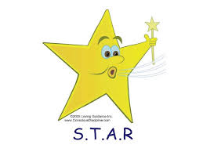

***The holidays can be a very stressful time for families. When you feel the stress take time to be a STAR!***

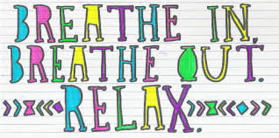

[](http://www.bing.com/images/search?q=music+notes&view=detail&id=53AA7E7BCCBE954D8F1A6535FE9719202E2E1FF9)**Group Music on Fridays**

All classrooms meet in the gym at 11:00 am & 3:00 pm to sing together. Parents our welcome to join us.

1. *The brain is* ***pattern seeking*** *and* ***survival-oriented.***
2. ***Connections*** *on the outside with others build connections on the inside.*
3. *The brain functions optimally when the child feels* ***safe****.*

* *Web to web*
* *Not too hard and not too soft*
* *Make eye contact*
* *Hi my name is _______. Have child work on full name, not just first if ready.*
* *Ask, “What’s your name?”*



***And then say, “Hi.”***

*There is a large visual of the poem on back so that you can practice at home. This is a* ***Tool for Triumph*** *that is not tested, but is a life skill that can make all the difference!*

**BE SURE TO CHECK THE WEBSITE FOR ADDITIONAL PICTURES OF WHAT IS HAPPENING WITH OUR GARDENS!!**

[](http://www.bing.com/images/search?q=music+notes&view=detail&id=53AA7E7BCCBE954D8F1A6535FE9719202E2E1FF9)**Group Music on Fridays**

All classrooms meet in the gym at 11:00am & 3:00 pm to sing together. Parents our welcome to join us.

This week the morning class surprised Mrs. Doney, our secretary, with a thank you song complete with rhythm sticks. The PM class is making a book for Mr. Lyon, our rocking chair reader, who is recovering from surgery. Some of the children have been making pictures and cards for each other. We still hope to do something special for our bus drivers.

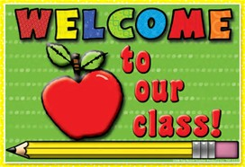

The afternoon class did a great job of welcoming **Karanveer** to our class last Friday. He comes to us from India with limited English and had a great first day. Welcome…welcome!

Those who have another year of preschool will also be transitioning to the role of the older students in class. It will be their job to help the little ones next year.

**Turning TATTLING into learning.**

Child: “Teacher, he’s not cleaning up.”

Teacher: “Are you telling me to be helpful or hurtful?”

Child: “Helpful (or hurtful).”

Teacher: What could you say to him to be helpful?

Child: I don’t know.

Teacher: Try saying, “It’s time to clean up, would you like some help?”

**See the trash.**

**Do the dash.**

**Pick it up.**

*(Help your child find the rhyming words in this little poem. Trash-dash, they both say “ash.”)*

**We teach manners in order maintain a civilized society.**

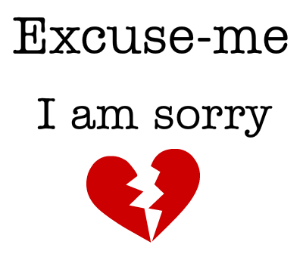

*We didn’t really get to focus on this tool last week too much, so we will continue this week.*

**Can you child give this information about him/herself in a full sentence?**

*My name is (first and last name).*

*I am ____ years old.*

*I am a (boy/girl).*

*I live at _________ (address).*

If not, please work on it at home.

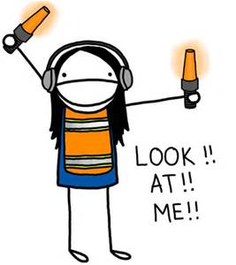**Children want to be noticed!** We try to describe what we see children doing. If it is helpful we celebrate! If it is hurtful, we figure out a helpful way to solve the problem.

Children will often hold the door for classmates at preschool. Adults can model this for children whenever possible.

**SERVICE**

We had several families take us upon the Martin Luther King Service Day Challenge. Next time you are in the building, check out the bulletin board in the gym and see the many ways are families are caring for each other and people in the community. Warms the heart! See back for some of the Yellow Room ideas.

**THANK YOU**

***We thank Will’s mom (Nanda****) for coming in and helping the children in the PM class recall the House of Tea experience. Please come and check out the bulletin board in the hallway!*

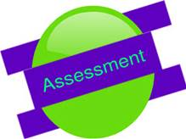

*During January, I will continue to assess your child’s development. If your child goes on to kindergarten, I will be asking you to fill out a Kindergarten Readiness Checklist. This will help me to plan for the rest of the year.*



have any questions. You never have to wait for a parent/teacher conference to communicate about anything in your child’s life. Our partnership is what makes for a great education for your child.

[**www.consciousdiscipline.com**](http://www.consciousdiscipline.com)**)**

**

**FOLLOW UP NOTES**

***Do you still have the newsletter from last week with the Hand Washing visual?*** *Please use it at home and see if your child can explain the steps to you. Some key vocabulary words to teach include:*

* Wet (many forget this step)
* Soap (1 or 2 pumps)
* Wash/Scrub (encourage them to sing the ABC song while scrubbing without having hands under the water.
* Rinse (most did not know this word)
* Dry/paper towel

*You can get the handout off the Knox County Health Department website:*

**http://www.knoxcountyhealth.org**

.

**ARRIVAL ROUTINE**

* Unzip backpack and give notes to teacher.
* Go to cubby and put papers in backpack. Zip up backpack.
* Put backpack and outer belongings in big bag.
* Hang big bag on hook.
* Move picture from the home side to school side on attendance board.

***We encourage the children to be independent and help each other out when needed.***

ost preschoolers do not have very much of a sense of time. We have been talking about those going to kindergarten next year, but it may not actually mean too much.

We will have paper chains counting down the last 8 days of school. Each day we cut one off and say:

When we get to the end, we will

* Put away the toys.
* Turn off the lights.
* Lock the doors.
* Go home for summer.

We also talk about some of the things they might do in the summer. We also tell them we will be looking for them around the town.

**Group Music on Fridays**

All classrooms meet in the gym at 11:00am & 3:00 pm to sing together. Parents are welcome to join.

Here were the key points emphasized with our Safe Touch discussions.

It is the job of grown ups to keep you safe. In the car, we wear a seatbelt to keep us safe. A grown up may hold our hand in the parking lot or to cross a street to keep us safe.

Hugs, high fives, fist bumps, are safe touches. Pushing, hitting, pulling on clothes….are not safe touches. It’s OK to say NO if a person is touching you in a way that is not comfortable.

Girls have 2 private parts. Boys have 1 private part. Private parts are covered by our swimsuits. A person should only touch your private parts to keep you clean and healthy (changing diapers/doctor visit). What do you do if someone is touching you in a way that is not safe? Say NO, run away, tell a grown up.

.

Simple factual information tends to be helpful to children. I told them Ms. Scott’s dad no longer breathes, walks, or eats food. His body has died. If children need more information, they will ask.



[**http://csefel.vanderbilt.edu**](http://csefel.vanderbilt.edu)

“Please take time to show me how to behave so that I don’t always have to test the limits. Sometimes you tell me but I don’t understand what you mean.”

Love,

The Preschool Child

Bullying is a hot topic these days. Learning how to be **assertive** instead of passive or aggressive will prevent your child from being a target or a bully.

Aggressive children and adults hit, scream, insult and so forth.

Passive children and adults whine and cry when they don’t get their way.

Assertive children and adults state their feelings about the matter and state the preferred behavior working towards solutions rather than excuses.

**Assertiveness is a learned skill. Adults must have it first.**

**Child grabs a car from a child at work.**

Teacher: “You wanted a turn with the car.”

“You may not grab it away. That may hurt _(child)__ or break the car.”

“When you want a toy someone else is playing with, say ‘I would like a turn’.”

“Do it now. Practice.”

**PARENT/TEACHER CONFERENCES**

*Conferences in MARCH will be for children who return to preschool next year. Children going to kindergarten will have their formal conference in MAY.*

Have you every been frustrated with your child’s behavior? It is so easy to focus on what we don’t want children to do. **You can’t change behavior by focusing on what you don’t want them to do. FOCUS ON WHAT YOU WANT YOUR CHILD TO DO.** Make images of what you do want them to do. Children under 6 years of age need visuals. They don’t have the inner speech we have to control behavior. So instead of saying, “Don’t run down the hall.” We say, “Walk down the hall like this” (and demonstrate. Notice this is very clear and specific for the child.

**When you are upset with your child, stop and ask yourself, “Am I focused on what I want or what I don’t want from the child?”**

**Remember to show and not just tell.**

**The motiviation to behave come from relationships!**

Children want to be **noticed.** They tire us out saying look at me, watch me, and listen to me. When we don’t take time to notice, children do things to make sure we notice (hit brother or sister, throw things….).

**NOTICING** is **describing** what you see. “You took your crayon and drew circles and squiggles using red, yellow and blue.”

**JUDGING** is placing a value. “You made a beautiful picture. Good job.”

**NOTICING** usually brings on continued conversation from the child and builds the relationship.

**NOTICING** focuses on the child’s accomplishment. “You crossed the beam without falling. You did it! Congratulations!

Children’s ability to learn is challenged when they do not feel **safe and secure**. We try to keep the Yellow Room a place where children know they are loved and safe. In this way, they can focus and concentrate on the learning through work and play. In addition, we work on children feeling connected in the classroom.

**\*\*Connection, not attention, is what all people seek. Loving moments of genuine connection literally wire the brain for impulse control and willingness.**

The first area of focus will be **composure** (anger management/being able to delay gratification). This means being the person you want your children to become. No one can make you angry without your permission. Learning how to remain calm is essential to social competence. It is no fun for adults or children to be out of control. If you think about it, nothing productive, in terms of solving the problem, usually comes from yelling & screaming at each other, hitting, name-calling, or destroying property.

***We are now encouraging the children to help each other with dressing and storing belongings.*** *We are asking them to ask a friend first before asking the teacher. This encourages a culture of helping in our school family.*

**Supporting Children’s Social Development**

*We are going to be focusing on ways to be* ***helpful.*** *It is too easy to focus on the hurtful things children and adults do. We want to show the children how they can take hurtful situations and turn them into helpful situations.*

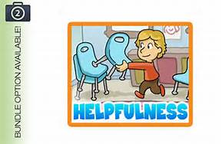

*We continue to write thank you notes to the grandparents. The not will be coming home in an envelope and has a picture with it. The children will also bring home a photo that is theirs to keep.*



**Collaboration Days**

We believe in partnering with families. The first collaboration half day is this Friday. AM class will not attend school so that teachers are free to collaborate with parents as needed. It could be in the form a home visit, phone conference, in person conference, IEP meeting, or even a small group activity. It could cover social, emotional, physical, or academic needs. Parents are also free to contact the teacher for a collaborative meeting.

We believe that all aspects of a child’s life impacts learning. Our goal is that we provide the best possible experience for success in school and life.

**LEARNING TO CALM**

All children are hardwired for these emotional responses. They happen naturally in life. Other emotional responses have to be **taught**.

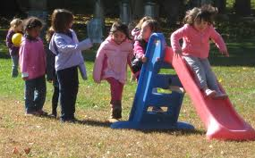

**PATIENCE & COOPERATION**

We have been working on learning these responses by waiting a turn, taking turns, and engaging in partner activities.

The morning class had a chance to learn the partner song “Shake A Friend’s Hand” where they had to work with a partner.

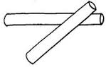

**(Name) came to school today.**

**We’re so glad we’ll shout hooray!**

We also focused on the fact that we are a “school family” in the Yellow Room and learned a family chant.

**Hands up high.**

**Hands down low**

**We are family wherever we go!**

and establish that we are a “school family.”

**Although we were sad to cancel Family Night, it did provide us the opportunity to talk about responding to disappointment. How did we respond?**

* We will still get to have the opportunity for a bouncy house experience on a warm day this week.
* We will probably get 2 days of ice cream for snack.
* Maybe we will talk about scheduling a rain date next time there is an outdoor activity.
* **We can’t control life, but we can control how we respond!**