C:\Users\TNewhall\AppData\Local\Microsoft\Windows\Temporary Internet Files\Content.IE5\WO573GAJ\MC900060293[1].wmf**Tadpoles**

**News from the Green Room**

September 19, 2014

We have exciting news!! Ms. Fox brought tadpoles for our classroom! Some have do not have legs, one has two back legs, and one has all four legs. We think there are two different types of frog tadpoles. We have been learning some new vocabulary words: life cycle, egg, hatch, tadpole, froglet, frog, amphibian, and webbed feet.

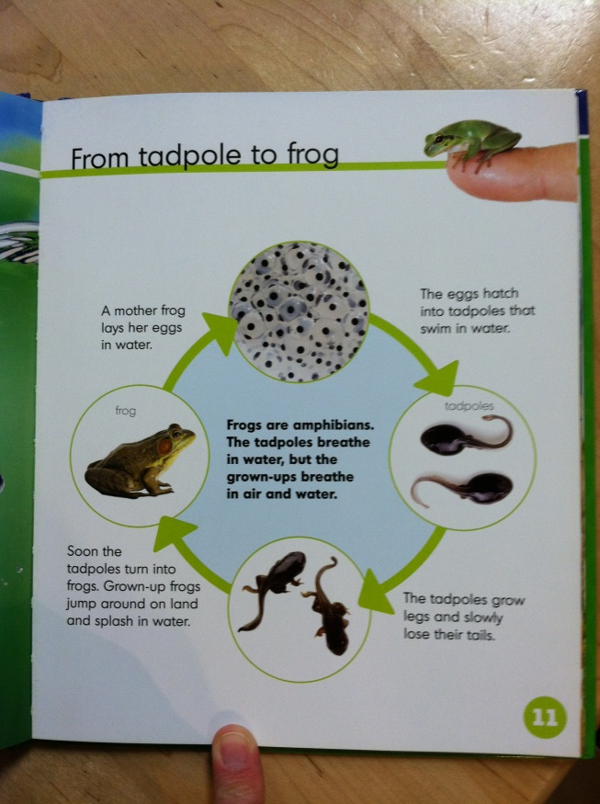

**Books this Week**

Monday – Pete the Cat: Rockin’

in My School Shoes

Tuesday – Pete the Cat: Four

Groovy Buttons

Wednesday – Pete the Cat: Old

MacDonald Had a Farm

Thursday – See Me Grow: Life

Cycles Book

Friday – Amazing Frogs and

Toads

**Snacks this Week**

Monday – raspberries &

blueberries

Tuesday – crackers & cheese

Wednesday – raspberries &

blueberries

Thursday – goldfish crackers

Friday – trail mix